Lab 14
Layer 3 Switches
Objective:
The purpose of this lab is for the student to understand Layer 3 switches. Students will also utilize IOS commands to explore and configure Layer 3 switches.
Diagram:

Components:
18 – PC’s with an Ethernet NIC
3 – Layer 3 Switches

Procedure:
- Connect all PC’s together and put their static IP addresses, subnet masks and gateways on them. Test connectivity by pinging each machine within the network.

- Label the switches VLAN IP addresses and ports below

Switch 1
VLAN IP Switch port
1 1.1.1.10/24 1
2 1.1.2.10/24 2
3 1.1.3.10/24 3
4 1.1.4.10/24 4
5 1.1.5.10/24 5
6 1.1.6.10/24 6
10 10.10.10.1/24 23

Switch 2
VLAN IP Switch port
1 2.2.1.10/24 1
2 2.2.2.10/24 2
3 2.2.3.10/24 3
4 2.2.4.10/24 4
5 2.2.5.10/24 5
6 2.2.6.10/24 6
10 10.10.10.2/24 23
11 11.11.11.1/24 24

Switch 3
VLAN IP Switch port
1 3.3.1.10/24 1
2 3.3.2.10/24 2
3 3.3.3.10/24 3
4 3.3.4.10/24 4
5 3.3.5.10/24 5
6 3.3.6.10/24 6
11 11.11.11.2/24 24

- Would route summarization benefit the routing tables? How?
Yes, the switches will be able to route traffic more generally and won’t have to learn as many routes.

- Label the routing tables for each switch below.

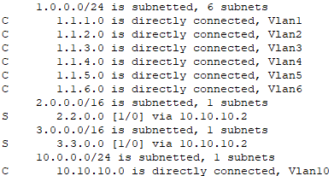
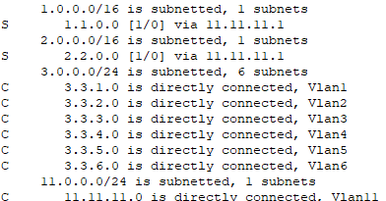
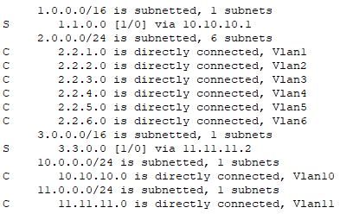
Switch 1 Switch 2 Switch 3

- Configure all of the switches vlan IP addresses. Place the switch ports into the proper vlans.

- View the routing table on the switches

  - Are there any routes in the switches? No

  - Why ? Routing was not turned on yet

- Enable routing on the switches

  - What command did you enter?
Ip routing
- View the routing table on the switches

  - Are there any routes in the switches? Yes

  - Why ? Ip routing was enabled

- Verify that the PC’s on the switches can ping each other locally.

- Connect the switches together

  - What type of cable do you use? I used a straight through, but I suppose you should use a crossover cable.

- Place the proper static routes on the switches

- Verify the PC’s can ping each other

- Does this design allow for any redundancy if any links between the switches fail? No, it does not.

- We are going to reconfigure the network to allow for redundancy.

- Label the switches VLAN IP addresses and ports below

Switch 1
VLAN IP Switch port
1 1.1.1.10/24 1
2 1.1.2.10/24 2
3 1.1.3.10/24 3
4 1.1.4.10/24 4
5 1.1.5.10/24 5
6 1.1.6.10/24 6
10 10.10.10.1/24 23, 24

Switch 2
VLAN IP Switch port
1 2.2.1.10/24 1
2 2.2.2.10/24 2
3 2.2.3.10/24 3
4 2.2.4.10/24 4
5 2.2.5.10/24 5
6 2.2.6.10/24 6
10 10.10.10.2/24 23,24

Switch 3
VLAN IP Switch port
1 3.3.1.10/24 1
2 3.3.2.10/24 2
3 3.3.3.10/24 3
4 3.3.4.10/24 4
5 3.3.5.10/24 5
6 3.3.6.10/24 6
10 10.10.10.3/24 23,24

- Label the routing tables for each switch below.

Switch 1 Switch 2 Switch 3
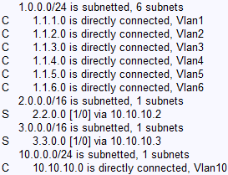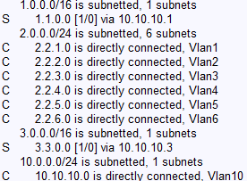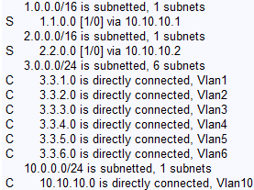

- Configure all of the switches vlan IP addresses. Place the switch ports into the proper vlans.

- Enable routing on the switches

- View the routing table on the switches

- Verify that the PC’s on the switches can ping each other locally.

- Place the proper static routes on the switches

- Verify the PC’s can ping each other

- Does this design allow for any redundancy if any links between the switches fail? Yes, there are redundancies now given that there are more connections between the switches.

- Please “write erase” your routers and switch(es). Also, Delete your vlan.dat file by issuing the following command: (delete flash:vlan.dat) on the switches. Not necessary on the routers.

- Draw the first lab diagram below (PC’s, and switch connections) ) Label the IP addresses, and subnet masks of each device. Feel free to use packet tracer or Visio, but do not copy and paste the diagram at the beginning of the lab. Screen shot your diagram and paste it below. Label VLAN and TRUNKS next to switches. Label the routing tables next to the switches and the switches vlan IP addresses and port vlan information.

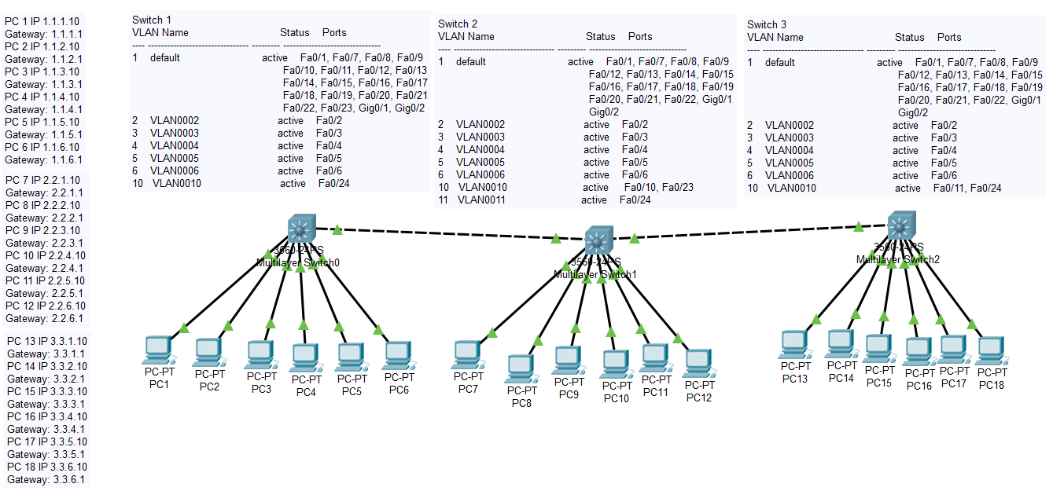




- Draw the second lab diagram below (PC’s, and switch connections) Label the IP addresses, subnet masks, and gateways used by each device. . Feel free to use packet tracer or Visio, but do not copy and paste the diagram at the beginning of the lab. Screen shot your diagram and paste it below. Label the routing tables next to the switches and the switches vlan IP addresses and port vlan information.

